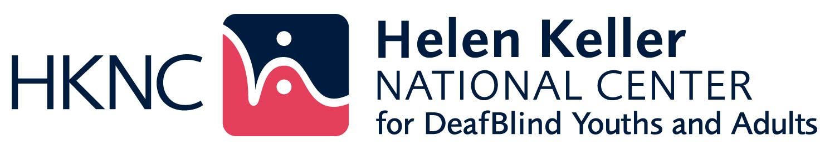

HKNC DeafBlind National Community of Practice (NCOP)

APPLICATION

Agency/Organization Name: _______________________________________________

_____________________________________________________________________________

Primary contact for this NCOP: ______________________________________

Primary contact’s mailing address:

__________________________________________________________________________

Telephone: Voice__________________________ FAX: _______________________

Video Phone: __________________________________________________________

Email: _________________________________________________________________

Website: _____________________________________________________________

Profile - Overview of your agency/organization’s services. Provide a brief summary of the following:

* Your agency’s history of services to individuals who are DeafBlind.
* Services currently available to individuals who are DeafBlind?

1. What is your agency’s definition of DeafBlind? (if available, attach document.)
2. Need for services
   1. What are your primary professional learning needs when working with individuals who are DeafBlind or who have combined loss of vision and hearing?
   2. How many consumers, who are DeafBlind, are in your state?
      1. Ages 0-22
      2. Ages 23 – 54
      3. Ages 55+
3. Presently, who is the primary rehabilitation services provider in your state for individuals who are DeafBlind?
4. If applicable, please describe your agency’s involvement with the National DeafBlind Equipment Distribution Program (iCanConnect).
5. What is your involvement with DeafBlind consumer organizations in your state?
6. Does your state have paid or unpaid SSP (support service provider) services? Is your agency/organization involved in these services? Please explain.
7. What expectations, other than those listed above, do you have from HKNC if you become a part of the NCOP?
8. Please include additional comments you would like to share with us about your agency/organization?

Return completed application to:

[pld@hknc.org](mailto:pld@hknc.org) or mail to

Helen Keller National Center for DeafBlind Youths & Adults

C/O Patrica Lynch

141 Middle Neck Road

Sands Point, NY 11050