

**Research to Practice Paper**

**Recognizing the Needs of Older Adults with Combined Vision and Hearing Loss**

Tara Brown-Ogilvie, Ph.D., Jenee Alleman, M.A., Megan Conway, Ph.D.

Helen Keller National Center for DeafBlind Youths and Adults

**August 2024**

# Introduction

* The aim of this nationwide survey was to learn about the service needs of older adults (age 55+) with combined vision and hearing loss. Also referred to as dual sensory loss (DSL) or DeafBlind.
* **334 survey responses were collected from 45 states and 3 U.S. Territories** *(Puerto Rico, Guam, and American Samoa)*.
* Of the 334 respondents**, 62.3% had not received services from HKNC,** showing that this survey reached those outside of HKNC’s national registry.
* The survey revealed **five common service needs** related to 1) support with daily activities, 2) reliable transportation, 3) socialization and well-being, 4) communication access, and 5) training for professionals in dual sensory loss.
* There was an expressed need for more assistive technology and mobility training.

*Please note that the statistics presented below are approximations and at times do not equal 100% due to rounding.*

# Demographics

## Age

* Mostly **55 to 75** (80%) with some older than 76 (20%).

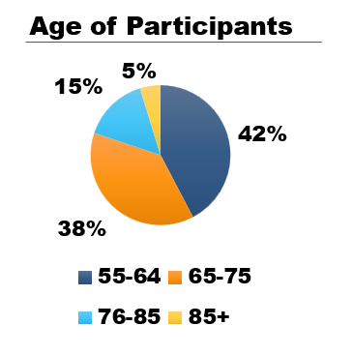

## Gender Expression

* Approximately 60% Female, 38% Male, 1% Non-Binary, and 1% other / prefer not to say.

## Spectrum of Vision & Hearing

* Mild to Moderate (Hard of Hearing) ~ 36%
* Moderate to Severe Hearing loss ~ 31%
* Profoundly Deaf ~ 25%
* Other (many write ins) ~ 8%
* Vision: Most participants reported being legally blind (52%), totally blind (22%), and low vision (25%).

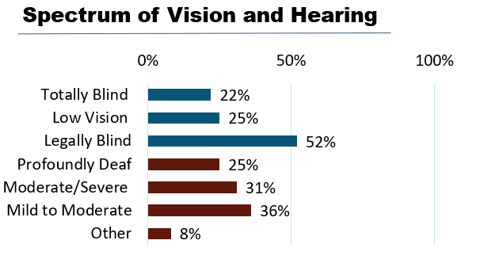

## Preferred Mode of Communication

* Speech (61%)
* Visual, tactile, or close vision ASL (45%)
* Reports of using both Speech and ASL (visual, tactile, or close vision) was less than (1%)
* Other modes of communication such as texting (56.4%), email (71.8%), video relay services (20.3%), and writing back and forth (15.1%) to communicate

61% speech users
with clipart image for speech

45% Visual and Tactile ASL
clip art image for sign langauge 

Numbers may be greater than 100 because some reported both Speech and ASL


## Living Situation

* Most living with a spouse, family member, or caretaker (45%)
* Living alone (33%)
* Nursing homes/assisted living (4%).
* Most commonly in suburban areas (61%), versus Urban (24%), and Rural (11%). With some write ins (4%) such as living in the Bahamas.

# 5 Key Findings: Significant Statistics & Quotes

## DeafBlind Older Adults expressed a great need for support with everyday activities.

* 67% reported difficulty with grocery shopping.
* 65% needed assistance with traveling independently.
* Others commented that they rely on a spouse, family member, etc., but wish they had a separate support person.

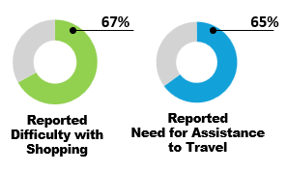

### Support Service Providers / Co-Navigators

* 29% reported currently receiving SSP / CN services.
* Some respondents that were not familiar with the term SSP/CN wrote about the need for a private driver, help in setting up and going to doctor’s appointments, and assistance with everyday tasks such as grocery shopping, reading mail, etc.

**Quotes:**

* We definitely need to be looking for ways to provide **SSP, Co-Navigation, and Communication Facilitator services for the DeafBlind** to reduce the impact of social isolation no matter where we live.
* Having **SSPs** available would be extremely helpful for grocery shopping, filling out forms, online requirements, traveling, attending social activities to help navigate and assist with communicating with others especially in dim lighting areas where you can't hear or read lips.
* We need funds to pay for **SSP** to help DB do their everyday tasks. SSP can’t volunteer all the time.

## 2. DeafBlind Older Adults reported a lack of reliable transportation.

* 33% of participants said lack of transportation was a barrier to them receiving services.
* 35% said people not being able to travel with them was a service barrier as well.

**Quotes:**

* I am totally isolated from participating with the deaf or the deaf/blind because of the distance and my **inability to use public transport**.
* It would be **wonderful to have a dependable driver** to take me to various places. Sometimes I would like my personal needs to stay private from family/friends. I don't want to depend on family/friends and take time away from them. Having a personal driver would make a huge difference in our independence.
* I foresee **needing a driver** to go to appointments and such and get help cleaning and such but not sure how I will afford it.

## 3. DeafBlind Older Adults expressed varying levels of isolation

* 32% of participants said, “Yes, I often feel isolated.”
* 47% of participants said, “Sometimes, I feel isolated.”
* 50% said they sometimes feel included In social activities.
* Only 13% reported being involved in a support group.

**Quotes:**

* **I feel isolated and alone.**
* **With no family to help, I wish there was support for those of us DB who are alone.** Can be hard to find trusted help. Also wish there was timely support when the unexpected happens. Can be scary. Trusted transportation can be a problem.
* **I choose not to go to big social events** as it is way too hard to hear and understand all that is going on. Too much input for my wife to explain.

## 4. DeafBlind Older Adults shared struggles in communicating with staff and medical professionals.

* 25% of participants report sufficient access to qualified ASL interpreters.
* 33% of participants reported limited access to qualified ASL interpreters.

**Quote:**

* Doctors and nurses are **still refusing to provide interpreters** here even when serious health problems exist.
* **A communication system such as phone needs to be available for deaf/blind so we are not isolated.**
* **Nurses need more sign language.** Hard to access VP without help. Deafblind specific support staff do not have a lot of availability to assist with all the deafblind residents.

## 5. DeafBlind Older Adults stated that staff and medical professionals could benefit from training

* 25% stated that staff did not understand Deafblindness.
* 12% state that staff could not communicate with them directly.

**Quote:**

* **Staff training is very much needed to learn how to assist DB people** of all ages, especially DB seniors, and for each stage of vision loss. We need to be treated as individuals, not as clients.
* **Training for medical personnel and/or personal services** such as banking, etc.: should be trained to understand the needs of persons with dual losses i.e., giving directions, (ex) to your left or right... and so much more...

# Additional Considerations

## DeafBlind Older Adults expressed need for more frequent access to the following training areas:

* + **Orientation & Mobility (O&M)**
    - Using public transit, getting around independently, etc.
    - 68.7% reported use of a white cane.
    - 13.5% reported the use of a guide dog.
    - Additional mobility aids (support cane, wheelchair, and walker) were less than 10%.
    - The top barrier for receiving services was not having someone to travel with them (35%).
  + **Assistive Technology (AT)**
    - iPhones, iPads, Computers, Braille Displays, etc.
    - Trouble with touch screens.
    - More need for haptic feedback.

## DeafBlind Older Adults and Employment

* 72% reported not working.
* Approximately 34% shared that they would like to work.

**Quotes:**

* Maybe **part time-or volunteer** as socialization outlet.
* I am retired but will pitch in and give back to the community either on a volunteer basis or temporary **part time employment.**

**DeafBlind Older Adults and Emergency Services**

* I have access to news, however when it comes to **weather or emergency alerts I don’t get that information.**

# Recommendations

* Promote Support Service Provider (SSP) / Co-Navigator (C/N) Programs.
* Advocate for better public transportation systems.
* Provide accessible opportunities for socialization.
* Improve communication access across settings.
* Train support staff and medical professionals on how to work with people who are DeafBlind.
* Promoting the use of accessible weather and emergency alert systems.
* Encourage follow-ups / wrap around services to meet needs that change over time.

# Taking Action

* HKNC partners with local, state, and national organizations who serve older adults (age 55+) with combined vision and hearing loss. This can include nursing homes, vocational rehabilitation, senior centers, and more.
* If you would like to collaborate, please reach out to our Older Adult Specialist, **Jenee Alleman**[***jalleman@helenkeller.org***](mailto:jalleman@helenkeller.org)
* You can also find additional resources on our website for [**Older Adult Programming**](https://www.helenkeller.org/hknc/older-adult-program/)**.**

### *For more information or questions, contact* [*PLD@hknc.org*](mailto:PLD@hknc.org)