

# SUMMER YOUTH VOCATIONAL PROGRAM (SYVP)

Are you looking for your first job or to try a new job? Are you looking to make some money this summer? Then SYVP is the program for you! HKNC’s Summer Youth Vocational Program (SYVP) will prepare you for employment and give you the confidence for starting life after high school. You can try out jobs based on your interests, talents, abilities and aspirations at several work sites.

# At SYVP you will:

* Work at a job you like and get paid for it
* Try out different jobs and share how you like them with your peers
* Take worksite tours and meet hiring managers
* Create your work portfolio and resume, and participate in practice interviews
* Understand your personal interests and strengths
* Learn from DeafBlind leaders how they applied advocacy to achieve success in college and their careers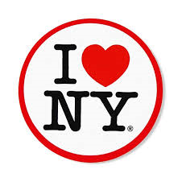
* Develop work readiness skills including personal care, managing meals, budgeting, travel and telecommunications
* Be a part of the youth summer groups who come to HKNC over the summer
* Join fun recreation activities and socialize with peers and staff
* Develop an action plan to meet your goals!

# Come to NY and join your peers ages 16-24 from around the country to learn skills that lead to employment success, and to experience what NY can offer you. Enjoy a boat ride, treasure hunt, talent show, swimming, crafts, Dave & Buster’s, mall shopping, bowling, BBQ’s and NYC! It will be 4 memorable weeks over your summer!

# Session I: June 2, 2025 – June 27, 2025 (Application deadline: April 4, 2025)

# Session II: July 14, 2025 – August 8, 2025 (Application deadline: May 9, 2025)

Contact your Regional Representative to find out how you can apply:

<https://www.helenkeller.org/hknc/nationwide-services>

HKNC SYVP Participant 9/1/24