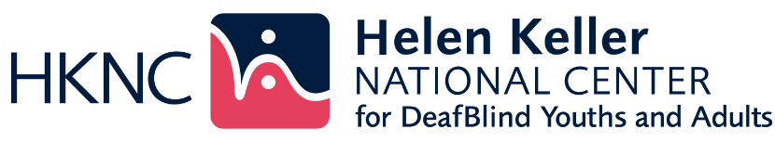

# SUMMER ASSESSMENT PROGRAM

**This summer empower yourself with knowledge, skills**

**and tools to determine your own future**

Come join us at HKNC this summer! Are you 16 years of age or older? Currently attending high school? Would you like to participate in career exploration or in identifying your next steps to college? Interested in meeting and socializing with others who are DeafBlind? Interested in working and learning together with peers? Interested in actual hands-on time with the latest advances in technology for gaining access to information and connecting to others?

The Summer Assessment Program will provide you with opportunities to gain knowledge and experience in the following areas:

* Career and Job Exploration
* Worksite Tours
* Living more independently on your own
* College and Accommodations
* Adaptive Technology and Communication
* Self-advocacy - Facilitating your IEP
* Orientation & Mobility
* Low Vision and Audiology
* Peer Learning Groups

# You can choose to join group classes such as Emergency Preparedness, ASL, physical fitness, and 3D printing. HKNC offers you a friendly, fun, and unique learning environment. Come learn what Vocational Rehabilitation is all about and what options exist for achieving your definition of success!

# Come join your peers ages 16-24 from around the country to identify goals and develop an action plan for your last years of High School. Prepare for college, a trade school or work. Experience NY with your peers during a fun-filled, action-packed program. Enjoy a boat ride, talent show, crafts, swimming, Dave & Buster’s, mall shopping, bowling, BBQ’s and NYC!

## Assessments are offered for four, six & eight weeks in June, July and August 2025

Contact your Regional Representative to find out how you can apply:

## <https://www.helenkeller.org/hknc/nationwide-services>

HKNC Summer Assessment Consumer 9/1/24