HKNC Logo


# Caregiver Tip Sheet

# Specific Considerations for Working with Individuals

# who are DeafBlind

Combined hearing and vision loss can significantly impact how individuals navigate their environment and communicate with others. As a caregiver, it's essential to ensure that those you serve have full access to their surroundings and the ability to engage meaningfully in their daily lives. Being familiar with the social norms related to approaching, communicating, and interacting with DeafBlind individuals will not only make interactions more respectful and enjoyable but also empower the person to participate fully and equally in their community. This tip sheet is designed to guide you in providing the best possible care and support for older adults who are DeafBlind.

## Who is DeafBlind?

The term DeafBlind refers to individuals with combined hearing and vision loss. Most people within the DeafBlind community have some residual vision and/or hearing. While individuals who are Deaf or hard of hearing rely on their vision and those who are blind or have low vision rely on their hearing, those who are DeafBlind need unique accommodations, techniques and tools to ensure that they can access information and communicate effectively, these often revolve around touch.

## How to Approach a DeafBlind Person

When approaching a DeafBlind person, let them know you are there by placing your hand on their shoulder. Maintain contact with the person until they visually or tactually locate you. Always identify yourself immediately.

[Video Demonstration](https://vimeo.com/580351758/8ae07354fe?share=copy)

## Communicating with Individuals who are DeafBlind

### Understanding the Individual’s Communication Preferences

People who are DeafBlind use different methods to communicate including sign language, speech, text and ProTactile language. Each DeafBlind person is unique, it is important to check in with the individual to determine what their preferred mode of communication is and then what accommodations they require to access this mode of communication. To learn more about effectively communicating with individuals who are DeafBlind please refer to:

### [Tips for Communicating with DeafBlind Individuals via Sign](https://www.helenkeller.org/resources/tips-for-communicating-with-deafblind-individuals-via-sign-language/)

### [Tips for Communicating with DeafBlind Individuals via Speech](https://www.helenkeller.org/resources/tips-for-communicating-with-deafblind-individuals-using-speech/)

### Print on Palm: Learn alternative ways to communicate with individuals who are DeafBlind.

[**POP Video Resource**](https://www.helenkeller.org/resources/print-on-palm-pop/)

## Ensuring Access and Inclusion:

**Provide visual and environmental information**

* Check with the individual to determine method for providing this information and type and amount of information wanted
* To learn more, go to: [Providing Access to Visual & Environmental Information](https://www.dropbox.com/scl/fi/zyfvbfs5wvszscfs5t8og/Providing-Access-to-Visual-and-Environmental-Information-for-Individuals-who-are-DeafBlind.docx?rlkey=2ewedeqbka7wborl96bk79pv0&st=uouc3f0g&dl=0)

**Orient individuals** to the area they are in. Let them know what and who is in the area. You can do this in sign language, speech or you can use hand under hand approach to guide them in tactually exploring the area.

* Video Demonstration: Here we have a young woman orienting, a DeafBlind woman to a table and dinner setting. Notice she uses hand-under-hand approach to guide her hand, first to the back of the chair and then the table. The woman then seats herself and the young woman again uses hand-under-hand approach to show her that there's a plate and utensils on the table in front of her.

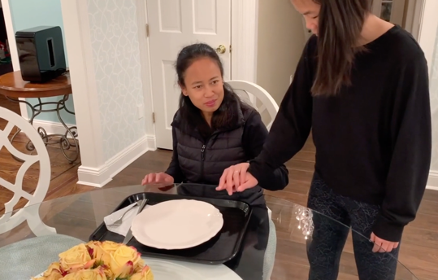

[Video Demonstration](https://vimeo.com/667855620/cca49ea4c8?share=copy)

* + Identify yourself and others when entering or leaving area
  + Make sure not to move items in common areas without informing the DeafBlind individual.
* **Making Materials Accessible:** Make sure that calendars, notices, all print information is provided in accessible formats. Check in with the individual to see what their print access needs are. Some include,
* Large print: determine preferred font size
  + Use sans-serif font (i.e., Arial)
* Avoid white paper as often causes glare and impedes vision
* Make sure there is a strong contrast between text and paper (i.e., light yellow or tan paper with black font)
* Braille (check to see if the person is a grade I or grade II user)
* Digital copy: often individuals have software on their computer, tablet or mobile device that allows them to modify the material to meet their needs. This means it may be easiest to send via email.

## Emergency:

Make sure to have a system in place to inform a DeafBlind individual that there is an emergency. The universal symbol for “Emergency” is an “X” drawn on the back with a person’s finger. This indicates that there is an emergency, and the person should stand up and allow the individual to guide them to safety. They will then receive an explanation.

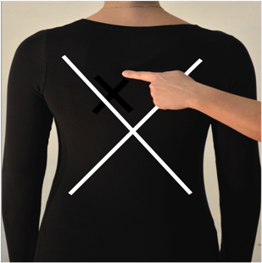

## Conclusion:

This tip sheet offers a brief introduction to working with DeafBlind individuals. For more in-depth information, resources, and professional training opportunities, please contact us to explore how we can support your learning and development.

Please contact us at [PLD@HelenKeller.org](mailto:PLD@HelenKeller.org) for more information.